Docker File Creation

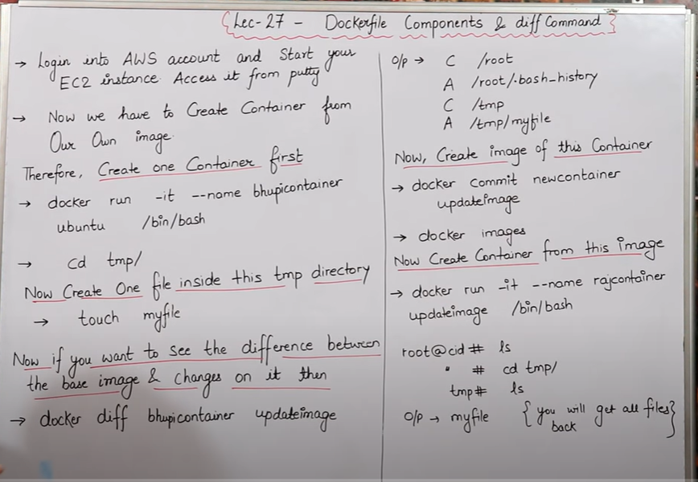

* Our container

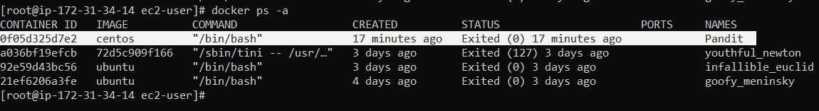

* First, we enter a **pandit** container and then we added some file to the container and after adding the file to the container we exit a container.

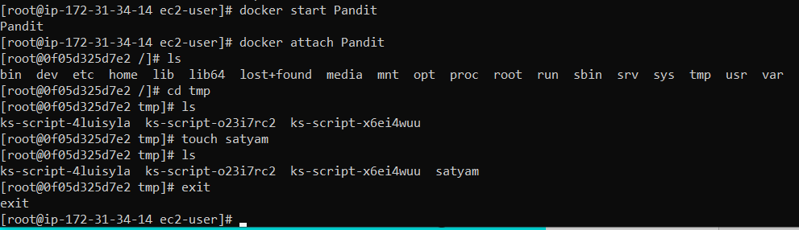

* If we want to see our changes in the container then we use this command to see what kind of changes have been done in the container.

**C /root =** it means changes in root directory.

**A / root/ .bash history =** it means changes save in .bash history

**C /tmp** = it means we change some things in this directory

**A /tmp / satyam** = it means we add satyam file in the tmp folder.

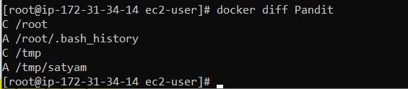

* Docker images:-

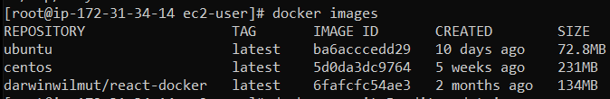

* **Convert container to image**
* If we want to update our container we use this command
* If I have done some work in my container and then I want to convert the container into an image then we will use this command for that.



* Now, we see our new image is created

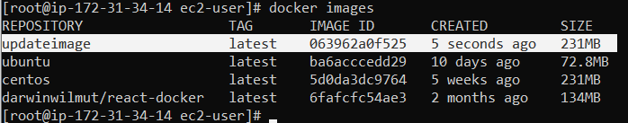

* Now we want to run our update image



* We use ls command to view our files :-



* we create previously in **tmp** folder we create file name is **satyam,** now we see in update image we can see file name satyam is visible.

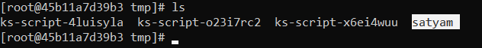

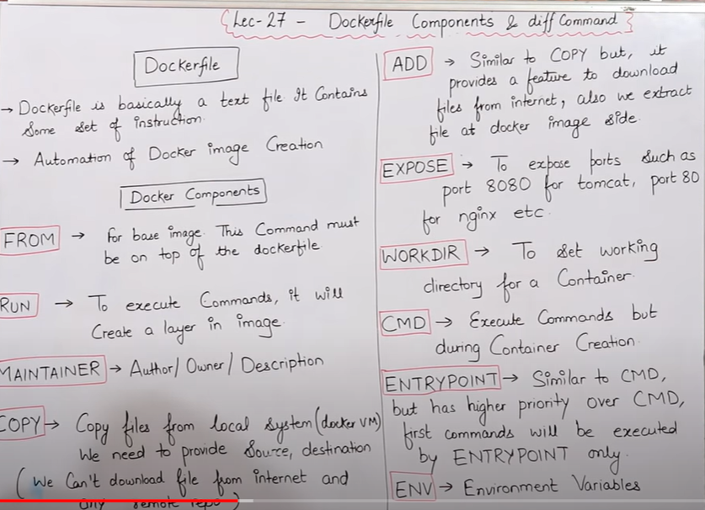

* Whenever we create a Docker file, we will keep its name only Docker file, can not name any other than Docker file
* Whenever we create a docker file, the first word of the docker file is always in capital D.

Ex = Dockerfile

* We will capitalize all the instructions inside the docker file.

Like = FROM, RUN , MAINTAINER, COPY, ADD, EXPOSE, WORKDIR, CMD, ENTRYPOINT, ENV

**HOW TO WRITE DOCKER FILE :-**

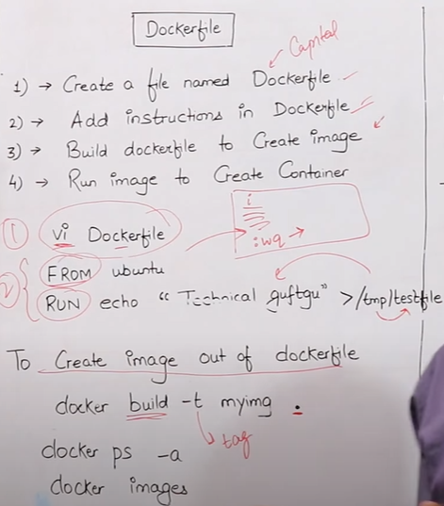

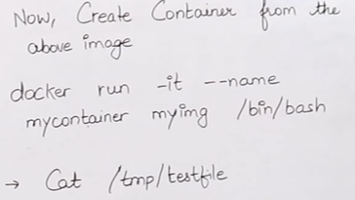

* Now we create a **Dockerfile**

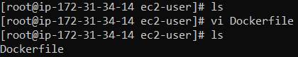

* we write operating system name in **FROM** line.
* hum jis bhi operating system ki image banana chahate hai us operating system ka naam hum **FROM** kein aage likhenge.
* **RUN** command mene is liye apane docker file mein likha hai kyu ki hum jo bhi dependencies aur script apane Docker file mein likh rahe un sab ko run karane ka kaam karta hai
* **RUN echo "hello satyam this is a temporary file " > /tmp/testfile** its means we create a testfile in tmp folder & inside a testfile we write some message **.**

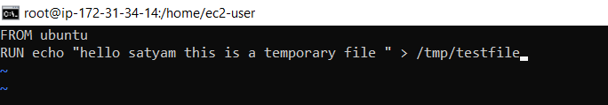

**Convert Dockerfile to docker image**

* We use this command to convert **Dockerfile** to **docker image**. docker build –t my-image .
* When we convert docker file to docker image, we use . always in last

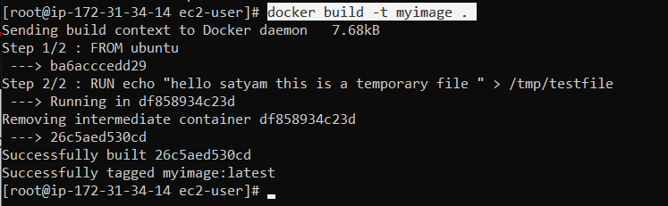

* Now we see our image is created .

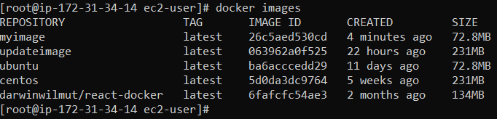

* **Our Container**

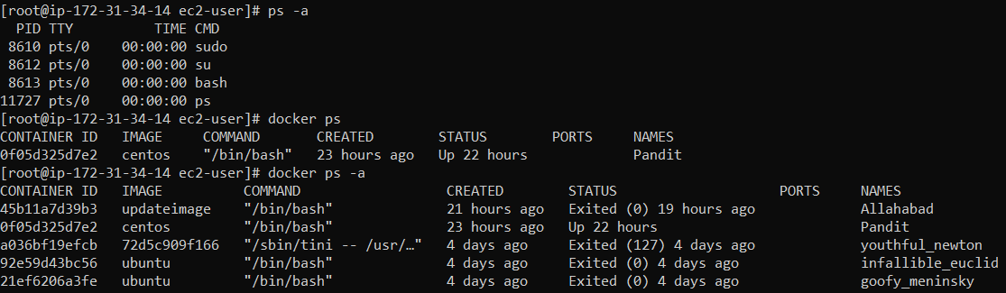

* Now, before running container we create a Dockerfile and inside a Dockerfile we write a testfile now, testfile is visible when container is running.

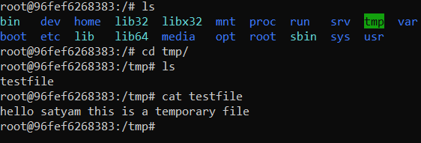

* Now , we edit Dockerfile

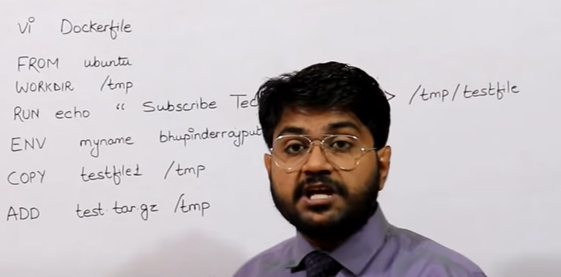

* Now, we again edit our Dockerfile





* WORKDIR / tmp it means our current working directory is tmp folder
* COPY testfile /tmp it means ki humare local machine mein sein testfile name sein jo file hai usko humare tmp folder mein daal do.
* ADD test .tar .gz /tmp it means ki humare local machine mein eak test naam ki file padi hai us file ko test file ko pehale tar file banao then uske baad us file ko zip file mein convert kar do.

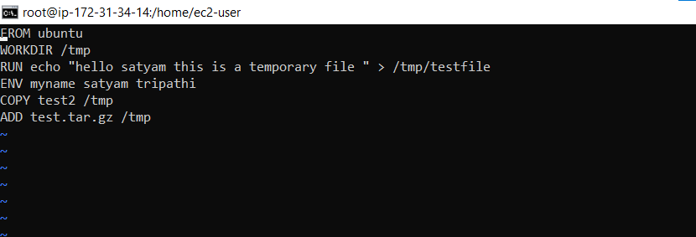

* Now we convert our test file into tar file

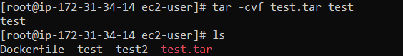

* Now we zipped our test.tar file



* Now, we remove our test file, kyuki mere bhai mene apane test file ko test.tar file mein bana diya aur usko zipped bhi kar diya haia toh humein ab zarurat nahi uski.

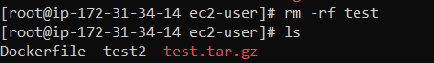

Docker images :-

s

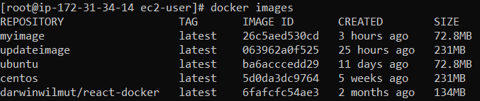

* Now, again we convert our docker file to docker image. Humane apane docker file mein jo bhi changes kiya thaa humane phir sein usi file sein eak new image create kar diya . hum dekh sakte haii ki docker eak –eak karke humari sab dependences install kar raha jo humane docker file mein de rakha thaa apane .

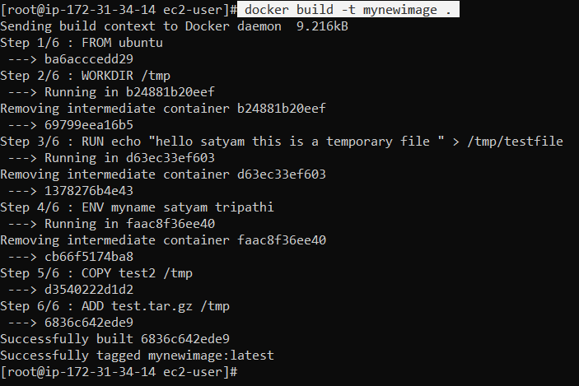

* Image created

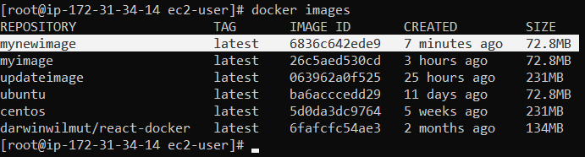

Docker container

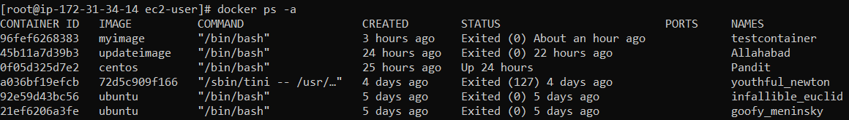

* Mene yaha **mynewcontainer** kein naam sein eak naya container banaya hai aur uske andar mene apani jo mynewimage banayi thii us image ko hi use kiya hai
* Mein yaha dekh sakta hu ki mene jaise container ko run iya usane turant hi container kein andar tmp folder mein mujhe lekar chala gaya kyu ki mene apaane docker file kein andar apani WORKDIR mein tmp folder ko efine kar rakha hai



* Now, we can see here in container, all details are come.
* humane jo bhi apane file mein de rakha thaa vo sab aagaya isme.

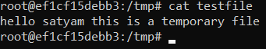

* If I want to know our environment we use this command
* Humane ENV apane docker file mein de rakha hai.

